**Faculty of Science and Engineering**

**Semester 2, 2016**

**IAB330 – Mobile App Development   
Assignment 1: UI Design and High Fidelity   
Due Date: In-Class (Week 6)  
Submission Method: Blackboard  
Weight:30% Overall Grade**

**Submission Coversheet Declaration**

You must sign below. By signing this form, you agree to the following:

* I/We declare that all of the work submitted for this assignment is our own original work except for material that is explicitly referenced and for which we have permission, or which is freely available (and also referenced).
* I/We agree that QUT may archive this assignment for an indefinite period of time, and use it in the future for educational purposes including, but not limited to: as an example of previous work; as the basis for assignments, lectures or tutorials; for comparison when scanning for plagiarism, etc.
* I/We agree to indemnify QUT and hold it blameless if copyright infringements are found in this work and the copyright owner takes action against QUT that is not covered by the normal terms of Educational Use.

The assignment should be attempted in a team of 2-3 students, and it is highly recommended that each team has the device you are developing for. Individual submission or a group of more than 3 is strongly discouraged. Consult with your tutor and unit coordinator if you have any issues.

|  |  |  |
| --- | --- | --- |
| **Team Member Details** | | |
| **Student Number** | **Student Name** | **Signature** |
| **N9552286** | **Yew Lren Chong** |  |
| **N9350179** | **Jes Shern Thing** |  |
| **N9532897** | **Tee Ken Lau** |  |
| **N9293400** | **Jianing Chang** |  |

**Related Apps Review**



**Glympse – Share GPS Location**

**Author: Yew Lren Chong**

**Google Play URL:** <https://play.google.com/store/apps/details?id=com.glympse.android.glympse>

**Screenshots:**

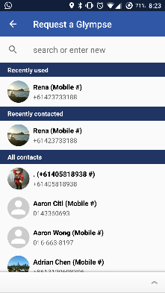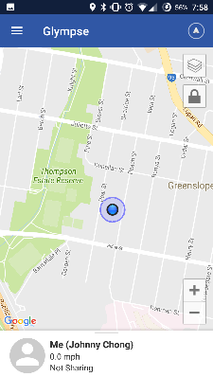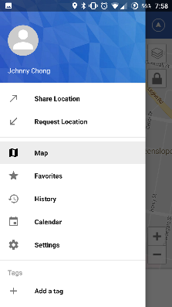

Splash Screen

Request Location

Menu

Home page

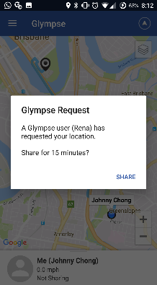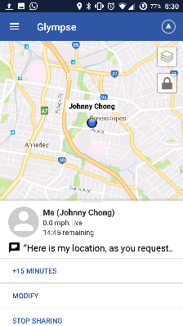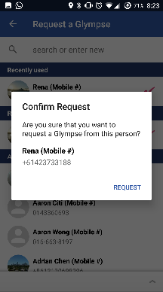

Sharing

Glympse Request

Confirm Request

**Description:** Glympse is a free and simple way to request or share location safely using GPS tracking in real time.

**How to use**:

1. Opening the app shows the splash screen briefly before the home screen is loaded.
2. To access the menu, slide right from the left edge of the screen or press the menu icon on the top left of the screen.
3. The two main features of this app are to share or request location. Choosing the request location option brings us to a contact list which is scrollable. New contact can be added by entering their mobile phone number in the search field.
4. A confirmation of request dialog appears after choosing a contact. A short message with a question and contact details are displayed in the dialog. Confirm the request by pressing the request button.
5. A notification will appear on the respondent’s screen. Opening the notification bring the respondent to the app with a dialog showing the glimpse request. Again, a short message is displayed in the dialog and tapping the share button confirms the request. A map with real-time GPS location is displayed on the screen with other information such as time remaining, message to requester, and stop sharing.

**Design & Interactivity**

**Positive**: The splash screen page is eye capturing with a simple logo and blue background. Overall colour and theme is simple and consistent throughout all the screens.

**Negative**: The app is supposed to a convenient tool to share users’ locations. The share location feature requires many steps to complete. There are too many options such as who, message, duration, and destination which lengthens the process of completing the task. As a result, users give up using the app and look for alternatives.

**Features & Functionality**

**Positive:** The map display and options are similar to google map which is familiar to most users. The calendar feature automatically syncs with the smartphone’s calendar events. Users are able to share their events from this feature which links to a location to share with other users. For instance, locations and estimated time of arrival can be seen by other attendees of a meeting or event.

**Negative**: The tag feature is confusing to users. Users are able to create a new tag which links to other users who uses the same tag. It was after many attempt until I learn how to use this feature. In my opinion, The feature can be scrapped as it clutters the app and confuses users.



**Life360 – Family Locator**

**Author: Yew Lren Chong**

**Google Play URL**: <https://play.google.com/store/apps/details?id=com.life360.android.safetymapd>

**Screenshot**:

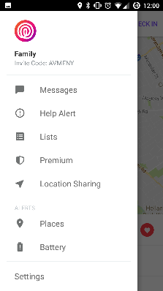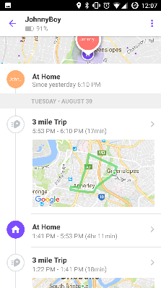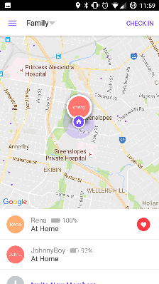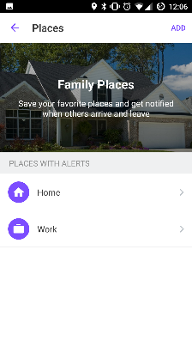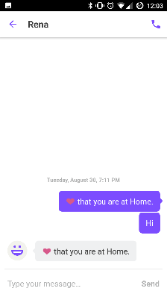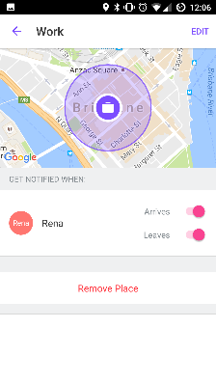

Places

Messages

Home

Timeline

Menu

Work

**Description**: Life360 is an app that uses GPS to track real time location. Aside from family, other circles such as friends or colleagues can be created. Members added to a circle appear on the map shown on the home page. Members of a group can chat with one another within the app. Users receive real time alerts when circle members arrive or leave a saved location.

**How to use**:

1. Opening the app shows a brief splash screen with a simple Life360 logo.
2. Tapping any names that appear on the home screen brings up a timeline of locations with detailed movement on a map.
3. New members can be added to a circle by selecting the “Invite New Members” option below the list of members on home page.
4. A user can check in to a place by selecting a location generated by Google nearby places (App uses Google Map API). Members in the circle will be notified of the check in no matter where they are.
5. To access the menu, slide right from the left edge of the screen or press the menu icon on the top left of the screen.
6. In the message feature, users can choose to chat from recent chat list or create new message to other users. Once a chat is opened, users can exchange text messages or call by pressing the call button at the top right of the screen. The call button opens the phone dialler and initiates the call automatically.
7. Users can save favourite places and get notified when others arrive and leave.

**Design & Interactivity**

**Positive**: The overall user experience and user interface is well designed. The app is inspired by Google’s material design concept which can be seen by the material icons used and the google card-like interface. The app is simple and easy to use but yet detailed enough to have very useful information such as the battery life of users. Complex abstraction can be seen in the timeline where important information is presented with minimal graphic and texts.

**Negative**: I am very satisfied with the design and interactivity of this app. Using the app gives me the impression that the creators have put in much thoughts in the interaction design of the app.

**Features & Functionality**

**Positive:** The developers make clever use of Google Map API by enhancing existing features such as getting notified if others arrive or leave a place. The chat feature eliminates the use of other messaging apps, thus prolonging the use of the app. Another two features worth noticing are the Help Alert and Lists feature. Help Alert notifies everyone in a group and up to three other contacts by tapping a button in the case of emergency and help. Lists feature adds extra value to the app by allowing users to create and share lists such as grocery lists and to-do lists to people in a group.

**Negative**: The only complaint that I have is the power consumption of the app. The app runs in the background and uses GPS to provide real time location. Before using the app, I get around 30% battery remaining after a full day of use, after using the app, I get around 10% remaining at the end of the day. In addition, notifications of the location updates are frequent and sometimes annoying.



**Skype**

**Author: Yew Lren Chong**

**Google Play URL**: <https://play.google.com/store/apps/details?id=com.skype.raider>

**Screenshots:**

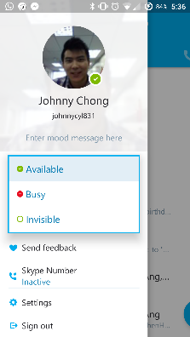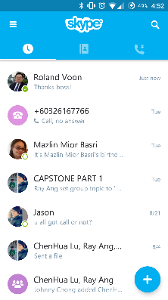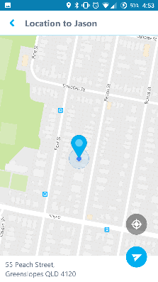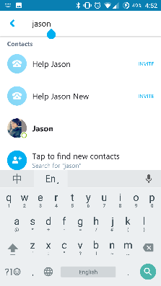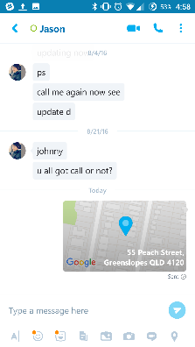

Menu

Chat

Share Location

Menu

Search

Home Screen

**Description**: Skype is a free instant messaging, voice or video call solution for all devices, regardless of operating systems. Like any other chatting software, Skype features sharing of photos, files, emoticons and even location.

**How to Use**:

1. Opening the app show a blank splash screen until the home page loads.
2. The design and interaction of the recent chats, contacts and recent calls is similar to what our team have in mind. Users can navigate to different screens by swiping left or right, or tapping one of the tabs above. The tab indicator indicates which screen is displayed.
3. The search button at the top right of the screen brings up a search page where a user can search for other contacts.
4. To access the menu, slide right from the left edge of the screen or press the menu icon on the top left of the screen. The menu is generally for settings and preferences. The main features are all accessible from the home screen or within a chat window.
5. Status can be changed by selecting one of the three options: available, busy or invisible. The available and busy status are made public to others while invisible makes a user appear offline, great feature if you do not want to be disturb by anyone.
6. In addition, a mood message tells everyone about your current mood and situation.
7. Within the chat window, users are able to share their location by selecting the location icon at the bottom right of the screen. A map appears and location can be set by dragging and dropping the pin to a desired location. The location shared is displayed on the chat window.

**Design & Interactivity**

**Positive**: The colours and theme are consistent throughout all the screens. The use of Android TabWidget to organize the recent chats, contacts and recent calls greatly reduces clutter in the screen, making it simple to navigate and use. The responsiveness of the app is excellent which can be seen in the transition of screens, button presses or actions.

**Negative**: The skype logo located at the top of the screen does nothing. Tapping the logo produces some animation but other than that, it has no functionality. The contact list does not have a scroll bar to scroll through long list of contacts.

**Features & Functionality**

**Positive:** The share location feature is useful and easy to use. It uses the google map API which is familiar to most users. Simplicity is present in the drag and drop interface while choosing a desired location to share. Sharing of status and mood message are visible to everyone which eliminates the need to send request.

**Negative**: I have no complaints about the features and functionality of Skype. The features are useful and functional. The only downside is that there is no unique selling point to differentiate itself from other competitors.

** When I Work – Employee Scheduling**

**Author: Jes Shern Thing**

**Google Play URL:** https://play.google.com/store/apps/details?id=com.thisclicks.wiw&hl=en

**Screenshots:**

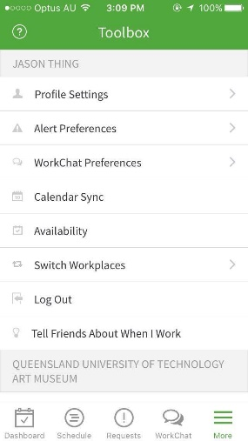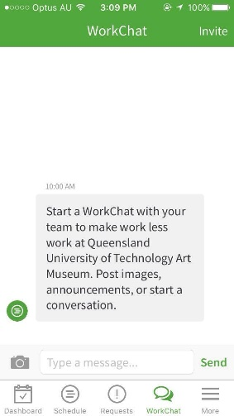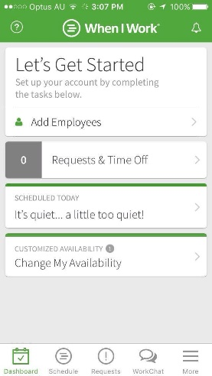

Extra Settings

Chat

Home page

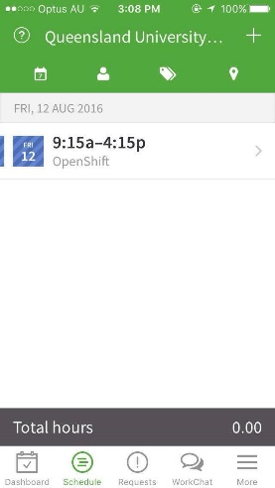

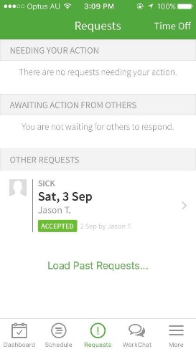

Requests Settings

Shift Settings

**Description:** When I work is a dashboarding/scheduling application designed for small to medium sized business, and helps employees and employers to manage their schedules and shifts.

**How to use**:

1. Opening the app will show the home screen of the app, giving users a view of the dashboard.
2. There are 5 tabs at the bottom, allowing users to tap and switch the screen to show either the schedules made, requests by employees, the in-built chat, and a settings screen.
3. The two main features of this app is to schedules shifts for employees. The feature however, comes with many other minor features to support it, for example allowing employees to request time off or change of shifts, and also allows users to view the availability of each other.
4. Shifts can be created in the dashboard, and users can choose themselves or other employees to assign to shifts.
5. The time for shifts can be changed anytime in the dashboard, and users can merely edit their shift by changing the time and date. Another good option is that users can also choose what type of shit will it be, e.g. unpaid break, sick leave and such.
6. Users can see the availability of other users, whereby users set their own available times in the dashboard too.

**Design & Interactivity**

**Positive**: Colour and theme of the app is consistent, all the functions and features are responsive and I did not experience and lags or crashes even when I tried creating up to 30 shifts.

**Negative**: The interface looks quite complicating, and it is safe to say that the app has little to no graphical design. It looks fairly complex for first time users, and may prompt users to feel that it is difficult to use.

**Features & Functionality**

**Positive:** It has a variety of functions built into it, and many of it applies to real life office situations. The request time out function is really useful for employees, and there are many sub-options in it such as the time, date, reason and such. Users are also able to modify their availability and shifts. One special feature of this app is that it allows users to create open shifts, meaning that any employee with similar roles are able to take up the open shifts.

**Negative**: Personally, I feel that the abundance of features itself may confuse users as it makes the app more complicated. Other than that, there are no real negative side of its features.

** GoToMeeting – Meeting Scheduling**

**Author: Jes Shern Thing**

**Google Play URL**: <https://itunes.apple.com/au/app/gotomeeting/id424104128?mt=8>

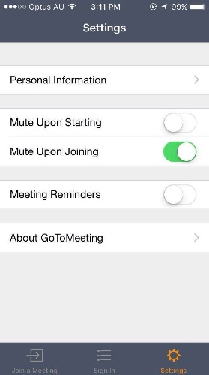**Screenshots**:

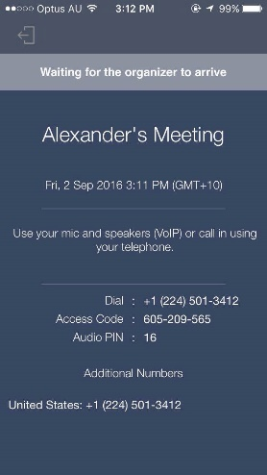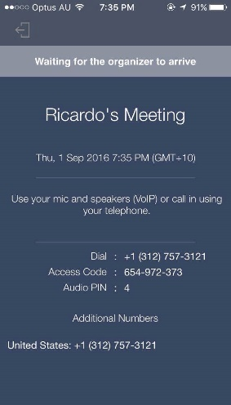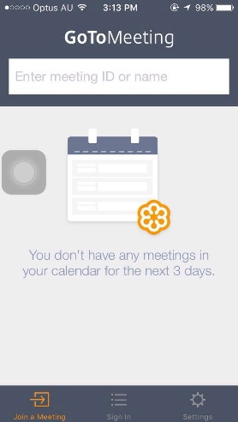

HomePage

HomePage

Meeting 1

Meeting 2

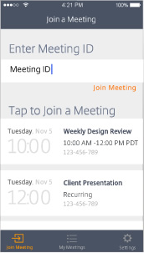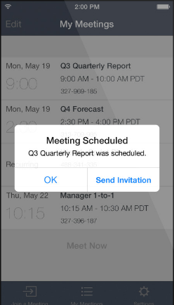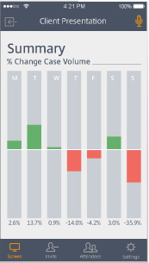

Meeting Sample

Schedule Meetings

Screen Sharing

**Description**: GoToMeeting is an app that allows users to join meetings and share files over the app. Not only that, but it has complex tools in place to also let users hold conference meetings with webcams, and also share screen to show presentations or slideshows.

**How to use**:

1. Opening the app will instantly bring users to the homepage which shows the scheduled meetings for the next three days.
2. Users can type out the meeting ID or name and join any meetings instantly.
3. The app syncs with the phone’s calendar, and this allows users to keep track of all meetings or events that they will have in the coming week.
4. Another feature for users is that they can directly sign in with their company ID, and this will sync all their details from their company.
5. Once inside a meeting, users can then choose to use their webcam or to share files in the meeting. Users just have to tap the arrow button and click share files or share screen.

**Design & Interactivity**

**Positive**: Overall, the app is really simple to use due to the interface which is well designed. At first look, the app looks really simple, but once users joins a meeting, there is a multitude of functions available for them. With only 3 tabs to navigate around, it makes it really easy for users to move around the app.

**Negative**: The app has some minor bugs for example when attempting to sign in, it crashed occasionally for me. When leaving a meeting, it may sometimes lag for about 20 seconds, which may be inconvenient for users. Other than that, there are no major cons about the app.

**Features & Functionality**

**Positive:** The developers had been wise to add features when inside a meeting. Allowing users to share slideshows and presentations inside the meeting is really useful, and users can also share their screen with other users. This app helps to save plenty of time compared to using other apps such as Skype, as Skype does not even support multiple webcam calls on mobile phones. Users could also share files among themselves as this app supports integration from cloud, dropbox and such.

**Negative**: As the objective of the app is to help users create and join meetings, I feel that it fulfils all of its objectives and only has some minor cons about it. For example, when having a webcam meeting with up to 6 people, the screens are really small and users can barely see each other. Of course, this problem is due to mobile phone sizes and not the app itself.

**Geozilla- Tracker**

**Author: Jes Shern Thing**

**Google Play URL**: <https://itunes.apple.com/us/app/id981856216?mt=8>

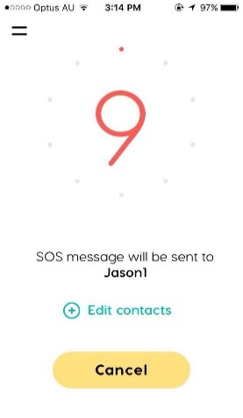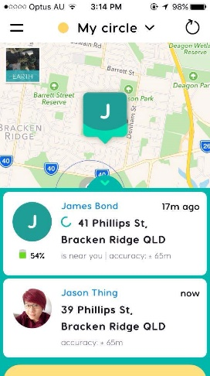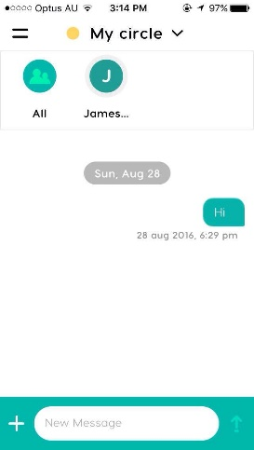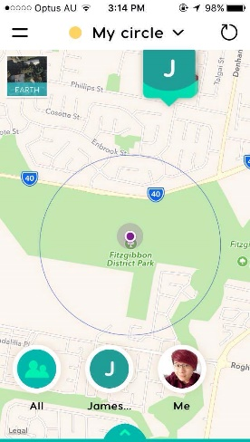**Screenshots:**

SOS Feature

Home Screen

Chat

PinPoint Location

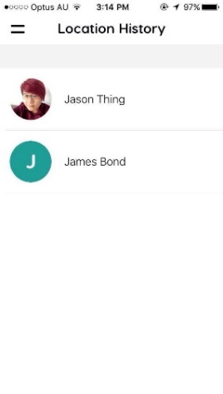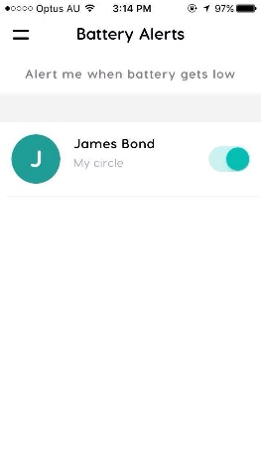

Battery Alert

Location History

**Description**: GeoZilla is the first AI-based GPS locator which helps users to share their location with friends and family, notifying them when and where they will be at a specific place. This app focuses on geographical locations and sharing it.

**How to Use**:

1. When the app is opened, it shows users a map. On the map, it shows where the user currently is, and where the locations of their contacts are.
2. Users can create circles and add members to it. Circles are made to provide more information for those in their circles, for example it allows users to see the battery life and location of those in their circles.
3. Users can then select specific places to pinpoint, and anyone entering or exiting that circle will prompt a notification for the user. For example, I have set a circle on a nearby park, and if any of my family members enters the park, I will be notified of it.
4. There is also an in-built chat system, allowing users to chat with other users in their circle.
5. There is a location history feature which allows users to see the previous locations of their contacts, and it even shows the time when they were in a specific location.
6. Emergency alert allows users to instantly send SOS messages to either their contacts or emergency services. Users just have to tap on the emergency alert tab and it will automatically send a SOS message in 10 seconds.

**Design & Interactivity**

**Positive**: The app itself is really simple to use, and I particularly like the interface as it is really user friendly. It is very easy to navigate around, and users can open up the navigation tab by just swiping to the right. The homepage of the app itself is the map showing users location and location of their contacts. The colour theme for the app is consistent.

**Negative**: Overall, I could find no faults in the interface and design of it.

**Features & Functionality**

**Positive:** The features of this app is very well thought-of, and I liked all of it. The “circle” feature which allows users to choose a location to view who enters and exit it is really useful, and it also relates to our app whereby we will be using beacons to track users rather than wifi and cell towers. Responsiveness of the app is very well, as there are no lags whatsoever. The app also features a battery saver function, which helps users to save battery. Allowing users to refresh the location of their contacts is so much more battery-friendly, and this app could last me a full day without charge compared to other location tracking apps which drains battery quickly.

**Negative**: In my opinion, I could see no negative areas of this app. Everything has been built very nicely and the functions were well thought off. The only disadvantage may be the number limit of people that users can add to their circles. Users would have to pay a small fee of 0.99$ to increase their limit of users.

# ../../Desktop/Screen%20Shot%202016-08-30%20at%2010.20.21%20PM.png **WeChat – Communication and real-time location sharing**

**Author: Jianing Chang**

**Google Play URL**: https://play.google.com/store/apps/details?id=com.tencent.mm

**Screenshots:**

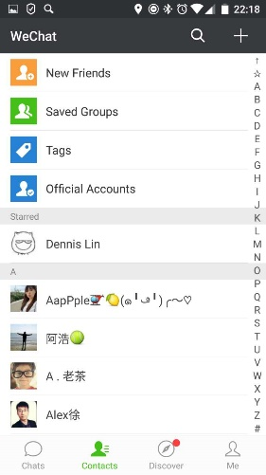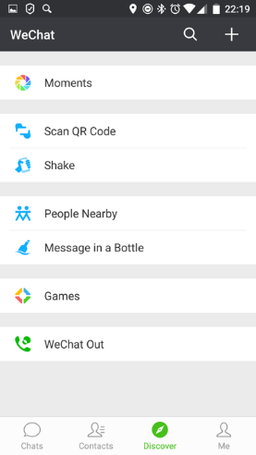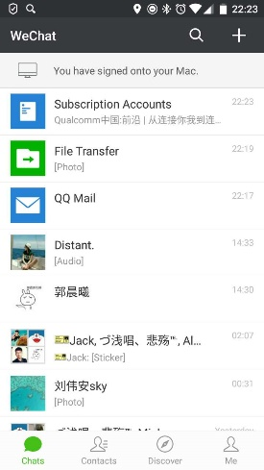

Discover Page

Contacts Page

Sharing Page

Real-Time Page

Profile Page

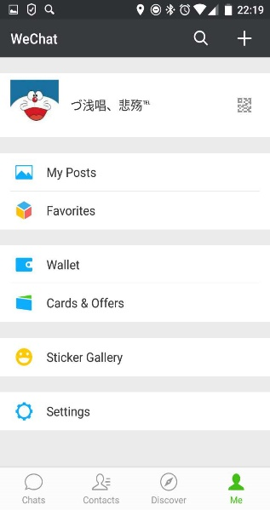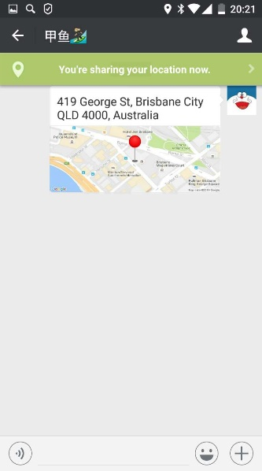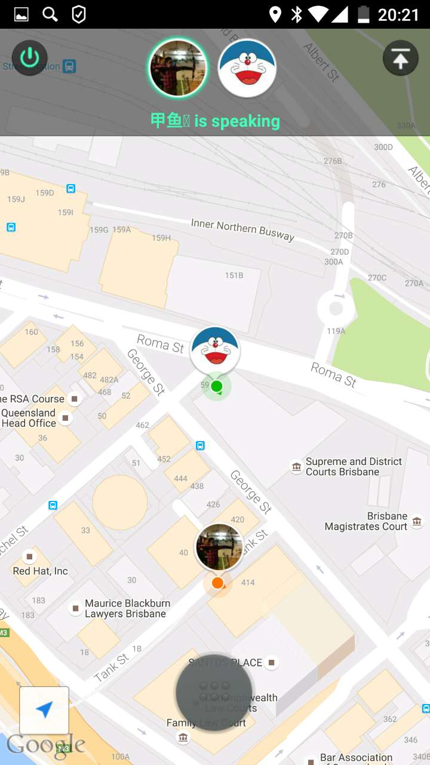

Sharing Page

**Description:**

WeChat is a messaging and calling app which allows users to easily connect with their families and friends across cities and countries.

**How to use:**

1. Open the app will bring uses to the chat list.
2. There are four main pages – Chats, Contacts, Discover and Me. Users can press the icon on navigation bar to go to these pages.
3. The three main functions of this app are chatting, sharing photos, and sharing locations. Users can chat with friends, share photos to friends and get other people’s location.
4. A notification will remind users that their friends sent messages to them.
5. Users can get one or more peoples’ location by using sharing location function.

**Design & Interactivity**

**Positive**: One of the design principles is easy-to-use. WeChat has a clear and user-friendly interface, which is simple enough that everyone can use it. That’s a very good aspect. When users start to use WeChat, they don’t need to worry about how I can use it or where the function is. Just open the page and find the functions they want. Also, as we all know, the flat design is clean and beautiful and becoming more and more popular in the world. It’s the design tendency. Thus, designers apply this design style to the WeChat and and make it fashionable and beautiful. Moreover, Colors can make a great design. For the WeChat app, there’s no messy feelings when users first see it. Colors are beautiful and comfortable. So, that’s the successful design—clear interface and comfortable UI.

**Features & Functionality**

**Positive**: As a communication app, WeChat is an all-in-one communication app for text, voice, video calls and VoIP, as well as some social functions like sharing photos, games, moments and locations. And there are two options in this function. One is “Send Location” and another is “Real-time Location”. For the first one, if you want your friends or families to find you, just send your current location to them, and the message receivers will get your detailed location information and see it on the map. For the second one, it is a highlight function of WeChat and it works differently. When you enable the real-time location sharing in WeChat, you will actually send a location sharing request to your friend so that they can join in the location sharing on mobile phone. Especially, anyone who joined in the real-time location sharing can see other’s location in real-time and meet with friends by navigation system until the location sharing is closed. It’s very convenient to help people find someone using smart phones.

**Negative**: When users login WeChat on a new phone or Computer, their message histories will be lost. There is no cloud backup function to storage user’s history or some important information. That is a big problem. And limited retrieval function is another big problem as well. For WeChat, there’s only one way to find the people in contact list—searching by the first letter of the username. Sometimes that’s not convenient. When users want to find a person but forgot his name, it’s hard to find him from large amount of contacts. Searching nearby people is good function, but users can find any other users within 100m. If you decide to find some person you want, WeChat cannot do it. So, that function can be enhanced. It should allow users to find specific people nearby, like friends, colleagues or families.

** WeChat – Family Locator**

**Author: Jianing Chang**

**Google Play URL**: <https://play.google.com/store/apps/details?id=com.careu.android>

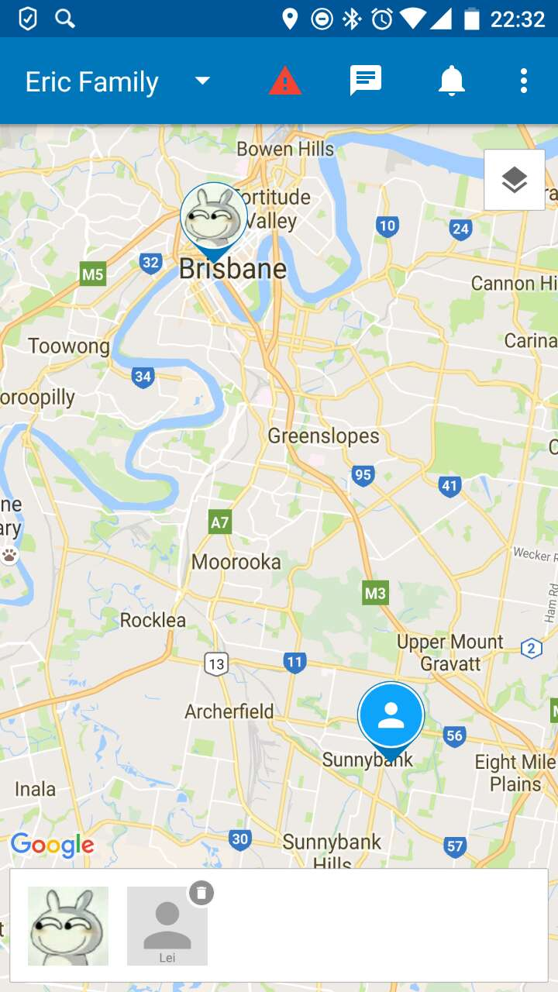**Screenshots:**

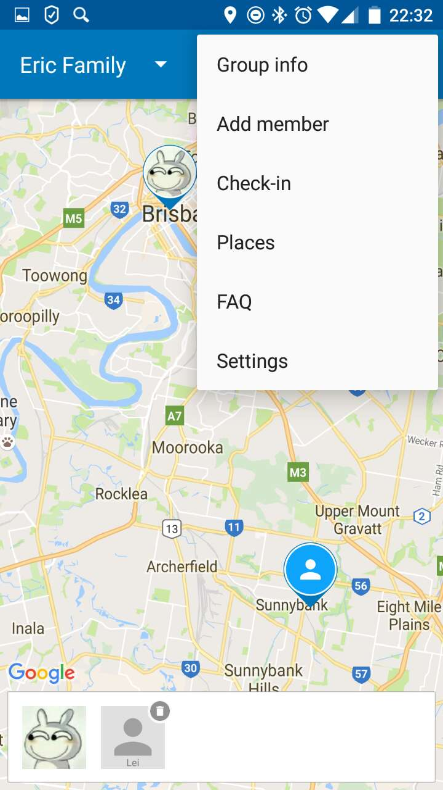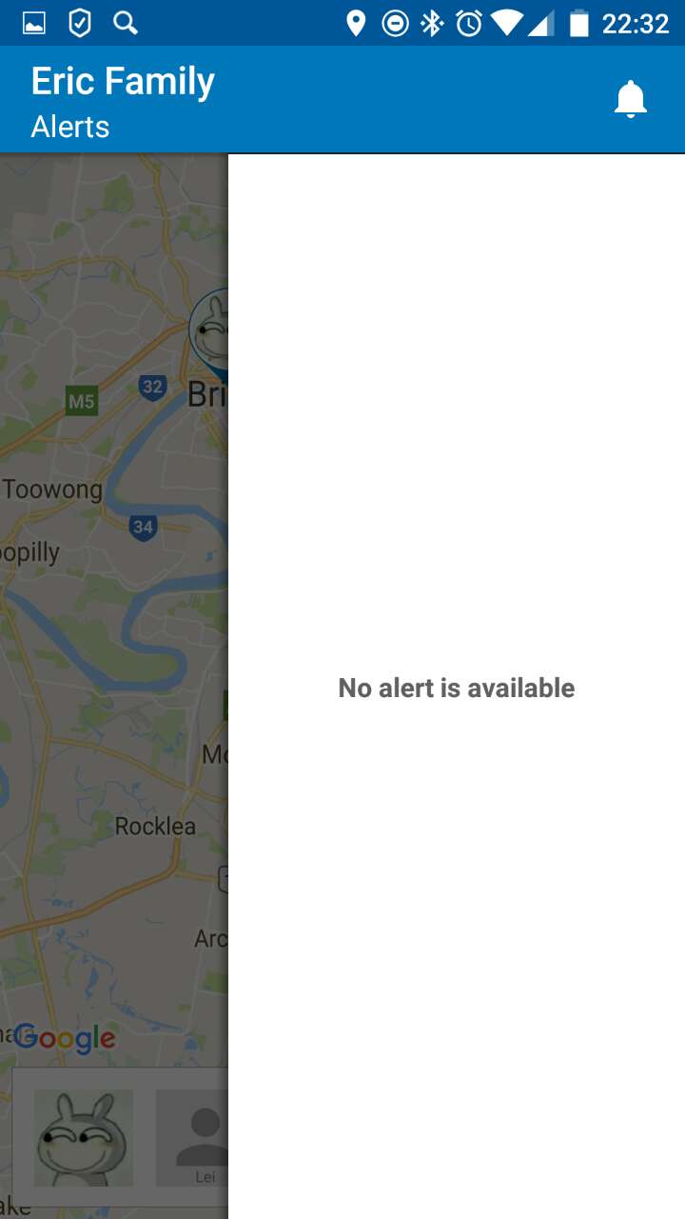

Main Page

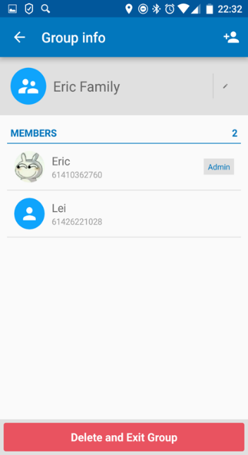

Alert Bar

Menu Bar

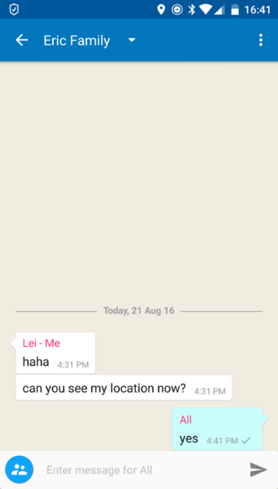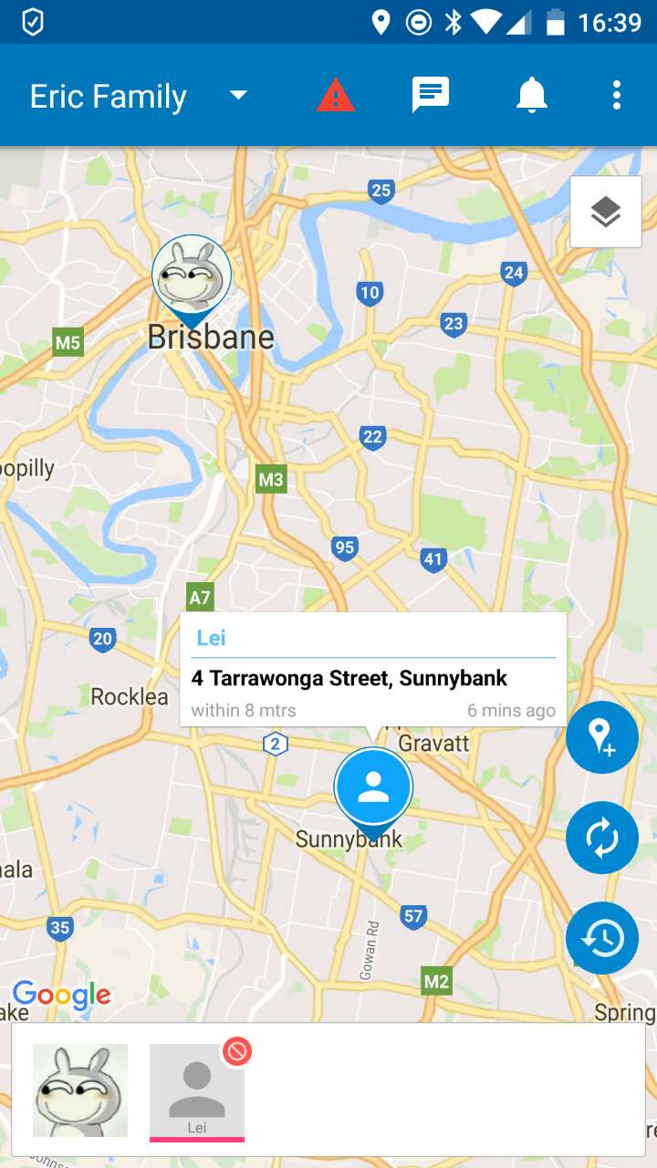

Add Member

Share Location

Communication

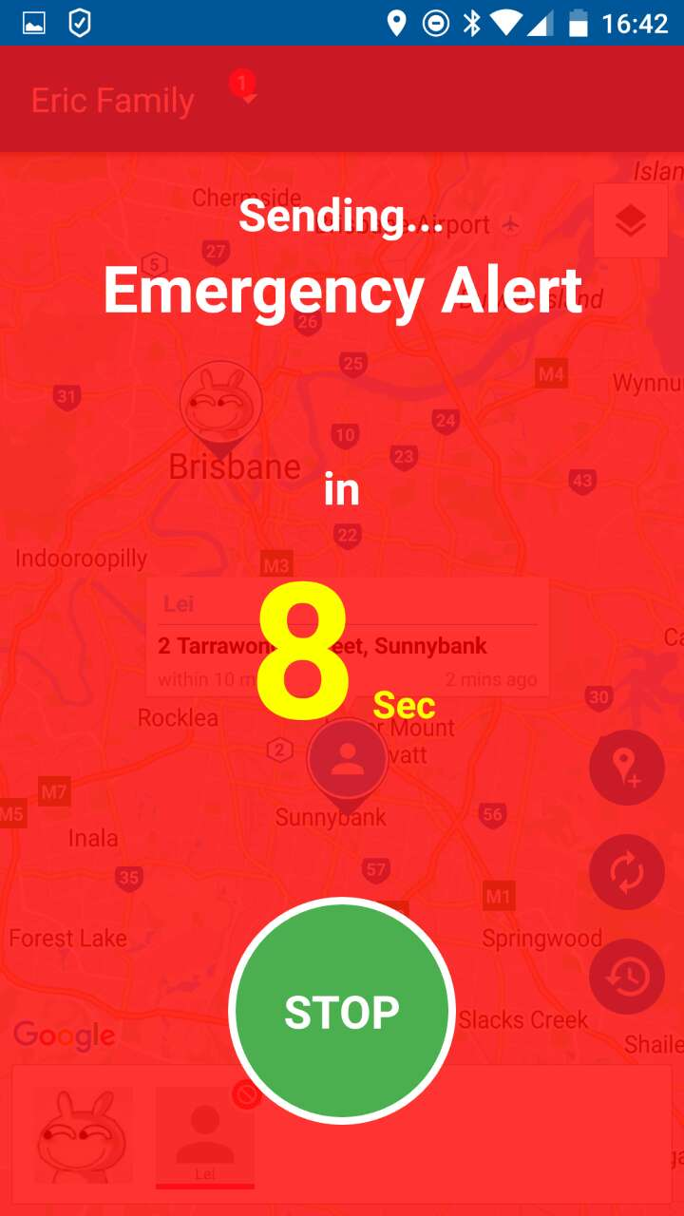

Alert Page

**Description:**

CareU is a app which can make you connect always with family members and bring you peace of mind by addressing your daily worries that you have, for the family and others who matter.

**How to use:**

1. Users are asked to verify their phone number and login or register when they first open this app
2. The main page of this app shows a map and marks users current locations
3. Users can add new groups or members by using the “Add member” function on the navigation bar
4. When successfully add a new member, users can see this new member’s location on the map.
5. Users can send messages by pressing “message” button on the navigation bar.
6. To press the red “alarm” button on the navigation bar, your alert message will be sent to others

**Designs & Interactivity:**

**Positive**: CareU has a clear interface which is easy enough for users to use it. There are three parts in this main page—tool bar at the top of the app, a map is in the middle of the screen showing each member’s location information and the photos bar placed at the bottom of the app. That’s a very good aspect, because for this kind of app, most users are focus on where the family members are. So, that’s the reason why designers decided to allocate a big area for the map and put it at the center of the screen. And for family members, they can upload their photos so that everyone can be recognized in the map. that’s a nice design, beautiful and useful. For design, as we all know, the flat design is clean and beautiful and becoming more and more popular in the world. Thus, designers apply this design style to the WeChat and and make it fashionable and beautiful.

**Features & Functionality**

**Positive**: The main function is “get location”. Users can get location and address, in real time, of members of their families and friends groups. In case of an emergency, the user can raise an alert to other group members with his current and complete location details, so that he can get a quick support. If the data is not available, the user can also send alert to others by message. Very useful function for children, women and old people’s safety. And users can also chat with an entire group or an individual online. And for family members, they can upload their photos so that everyone can be recognized in the map.

**Negative**: CareU doesn’t have any navigation functions. When one group member needs help, others can see his location on the map, but they cannot use real-time navigation to find a quickest and shortest way to get to the pointed location. Another big problem is that the positioning system is not accuracy sometimes and the orientation errors will happen. For a real example, when one group member sends his location to others two times, the receivers will get two different location details. Maybe this problem will slow the rescue efforts.

 **Team Locator**

**Author: Jianing Chang**

**Google Play URL:** <https://play.google.com/store/apps/details?id=com.tonikorin.team_locator>

**Screenshots:**

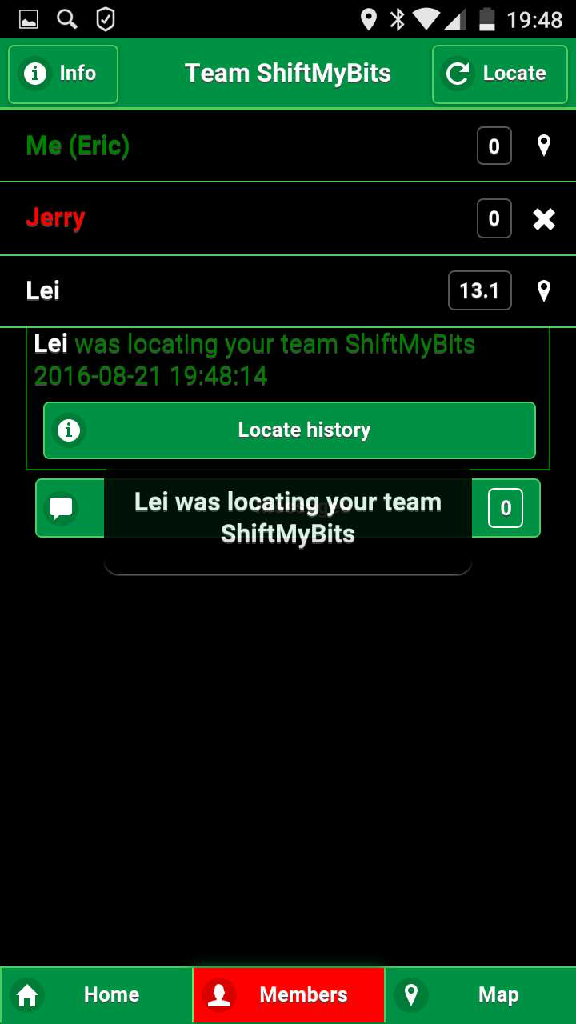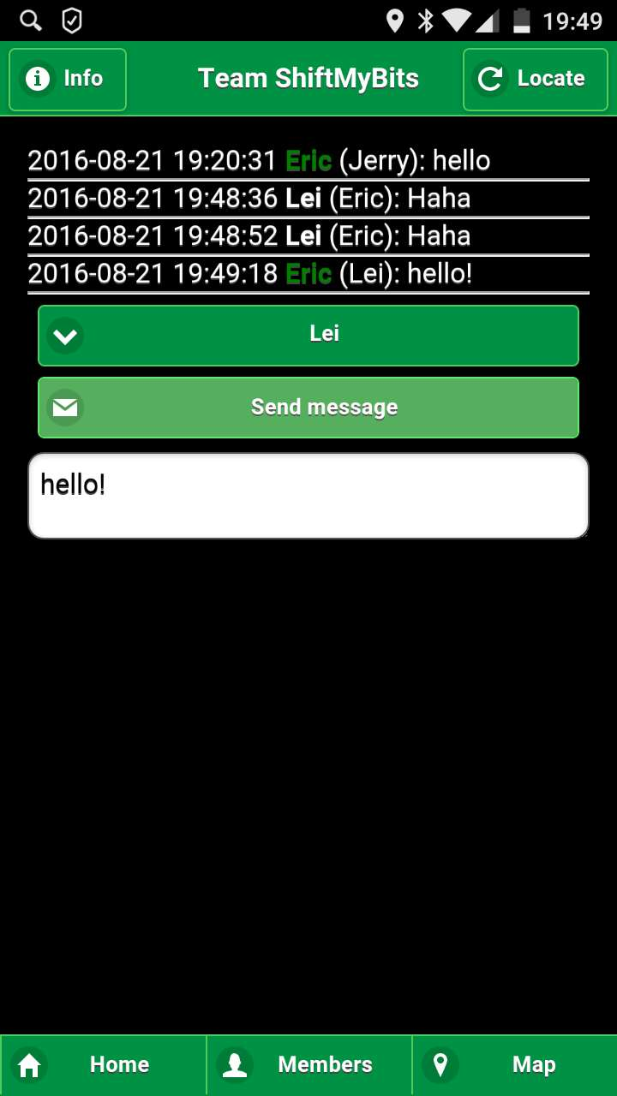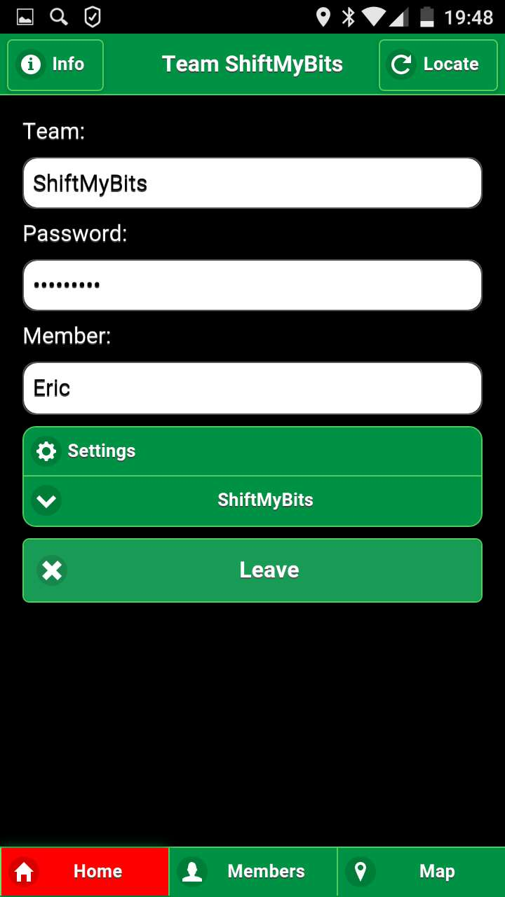 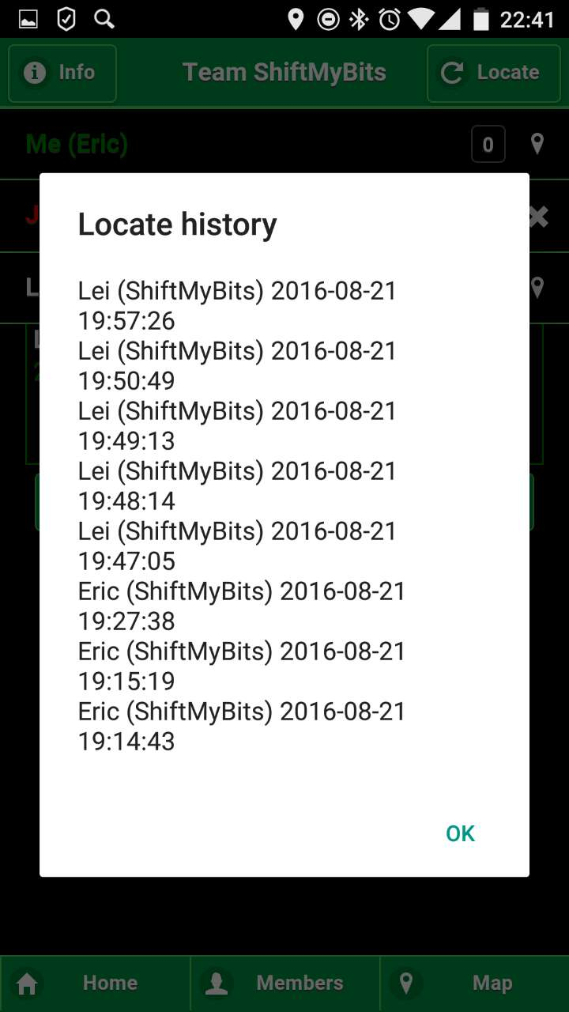

History Page

Member Page

Home

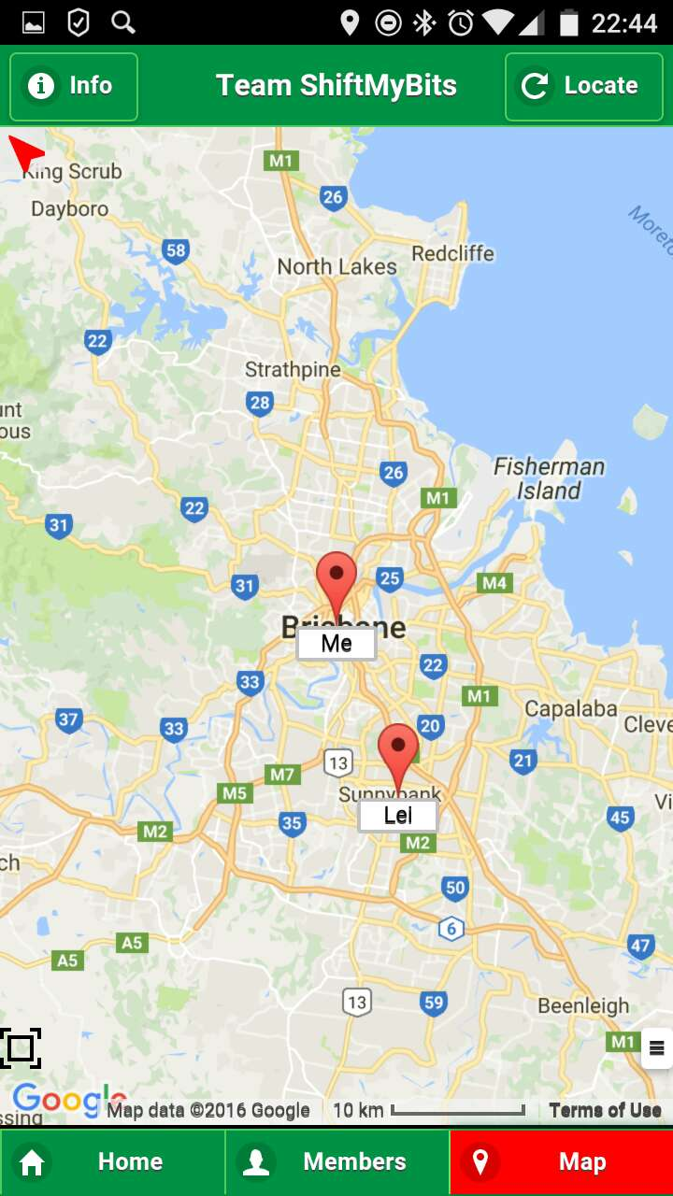

Communication

Map

**Description:** Team locator is used to locate any kind of team members. Each team member can send messages to others and find detailed locations on the map.

**How to use:**

1. Launching the app will show the “Home” page. And users are allowed to create a team, team’s password and a member in that page.
2. When create successfully, you can see your name in “member” page and current location in “Map” page.
3. Users can input team’s name, password and their names in the “home” page to join in this team.
4. Team members can chat with each other by using “messages” function in the “members” page.
5. Each team member can see others’ locations in the map in “map” page.

**Designs & Interactivity:**

**Positive:** Team Locator has a clear interface which is easy enough for users to use it. There are three buttons at the bottom of the app—Home, Member and Map. That’s a very good aspect, because most users are focus on chatting with other teams and find their location. So, clear interface and practicality are most important.

**Negative**: The fatal weakness is ugly interface---Green and Black are the main colors of this app. Obviously, it’s not beautiful, especially by comparing with other apps. Also, the UI is too simple.

**Features & Functionality:**

**Positive:** And one of the core functions is location sharing. People can get others’ location information and see theirs’ position on the map by using this app. Importantly, the location data is not stored to any external servers, so the location information is just shared between team members. For a team, it’s easy to join in a team. When administer creates a team, other team members can join in this team by inputting the team’ s name, password and their names. For team members, sometimes they want to see each other’s status information. For example, one team member’s mobile phone cannot provide positive information, then the app will highlight this team member and show an error or warning icon. So, it is easy to check status in the app. And team members can chat with others online as well. Furthermore, leaving uses can save team details for later use.

**Negative**: Team locator doesn’t have any navigation functions. When one group member needs help or want to find someone, others can see his location on the map, but they cannot use real-time navigation to find a quickest and shortest way to get to the pointed location.



**WhatsApp – Messaging and Location Sharing**

**Author: TeeKen Lau**

**iTunes Store URL:** <https://itunes.apple.com/au/app/whatsappmessenger/id310633997?mt=8>

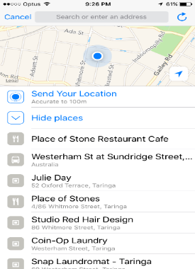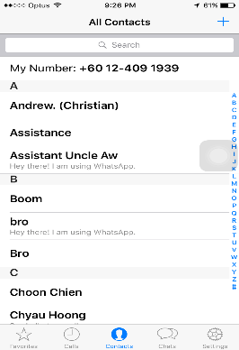**Screenshots:**

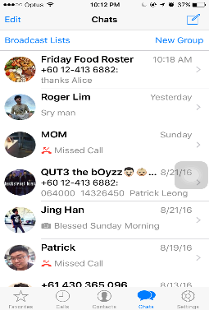

Chats(Home)

Contact List

Location Sharing

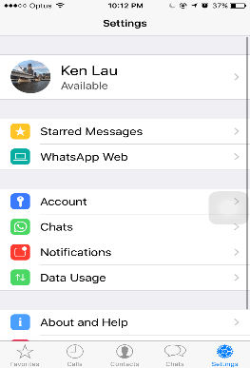

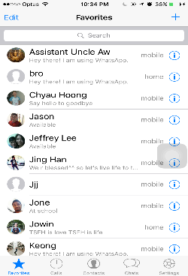

Favourites

Settings

**Description:** WhatsApp is one of most popular instant messaging app that has been intensively using by people for working and communication these days. It is multi-platform and encrypted instant messaging client for mobile devices. It is extremely good for sending text messages, documents video and so forth via internet or network.

**How to Use:**

1. Launching the app will brings users to the chat list.
2. There five main categories or tabs in the apps includes favourite, calls, contacts, chats and settings. To access all these categories, you have to press icon on bottom navigation bar to change activities.
3. The three main features of this app are to share location, chat, make phone call. Users able to create one-to-one or group conversations. The contact list can be automatically added from the local contacts in the device.
4. A notification that remind users the new message or location have been sent through chat. Users will be notified with call alerts when someone is calling via the app.
5. Opening notification will bring users to the page where the message, location sharing text or calls were located. Users can send their location to the people that are belongs to the particular chat session.
6. User can update their details such as the availability or account-related details through settings which is available on the app. The search

**Design & Interactivity**

**Positive**: There’s no splash screen or start-up pages make it easier to use as the users are not required to wait for the splash screen to be loaded. The tabbed host contains all four main categories is fairly well designed. The consistent use of colours and responsiveness of layout changes make it responsive to the users. The appropriate use of component model makes it looks better as the users are not confused and easily performed the activities. The navigation of activities is simple and can be done in just a few clicks. For instances, users can directly create a new chatting group by clicking the adding button and inviting the people that they want to add. Besides, the users can easily share their location by navigating optional bar. From there, users can share their location or nearby places if they want to.

**Negative**: The interactivity and responsive is incredibly good in this app. However, the app is not designed to categorize the type conversation such as one-to-one or group. They are all bundled together and the users can be easily confused and need to search it whether it is individual or group chat.

**Features & Functionality:**

**Positive**: One of interesting features available in this app is data tracking and usage. Users can turn on the low data usage when they are at outside or not at home. The features eliminate the unnecessary app that are not currently using. It can be saved up massive amount of network data and it is prolonging the device’s battery life. Most importantly, users can select and choose the type of documents they want to receive or send when WI-FI or cellular is available. The app has provided great and interactive map, including landmarks such as schools, parks or historical places. User can easily send their location by clicking the red popping icon shown in the map.

**Negative**: The app has pretty and fairly well designed features and its function



**Family Map – Location Tracking**

**Author: TeeKen Lau**

**iTunes Store URL**: <https://itunes.apple.com/au/app/family-map-find-my-family/id1012640971?mt=8>

**Screenshots:**

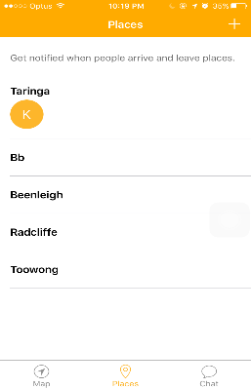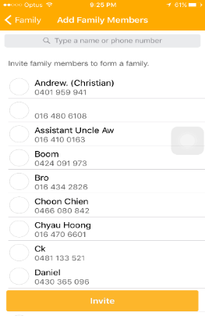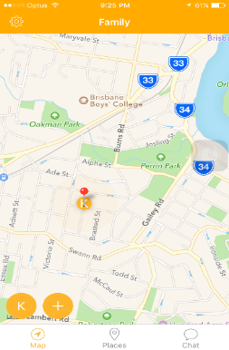

Home

Alert Place

Add Member

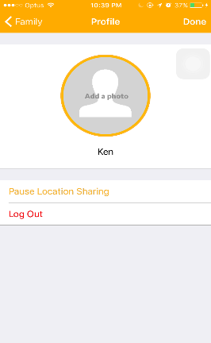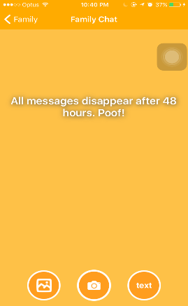

Chat

Setting



**Description:** Family Map is one of popular location-based app in mobile market these days. It has great and effective combination of techniques to determine the users’ location via phone. People usually use it to track safety or location of their families and friends around the world.

**How to Use:**

1. Launching the app brings up the splash screen and reminders of adding new member to the contact list in the app.
2. The interactive and multi-panning map appears after the splash screen is loaded. Pressing the icon with initial names will show the users the location of that particular person details.
3. New members can be added to the social circle by pressing the adding icon which is located on bottom-left of screen. The member belongs to the particular social circle can view location of everyone in the map.
4. Users can disable the location sharing feature to the member belongs to the particular social circles.
5. To access profile menu, users have to press the setting icon located on top-right of screen. The profile details can be updated from there as well.
6. User can create and save new place and get notified when members arrive or leave.
7. User can send the message in form of text, images or photos to the family chat by navigating to the chats. The members belong to the particular social circle will received the notification of message sent by others.

**Designs & Interactivity:**

**Positive**: The user interfaces and design is generally and fairly well designed. The navigation of activities such as swiping to the chatting sessions or adding new member is simple and easy to the user to perform task in just in seconds. The consistent use of yellow colour in most component model such as navigation bar, tabbed hosts, icon and selected theme make it looks better. The responsiveness of buttons and navigation bar make it more interactive to the users. It is simple and detailed with necessary and useful information to the users. Most importantly, the appropriate use of graphical animation and text customization make it looks even better and favourable.

**Negative**: However, the layout design and component arrangement designed in the family chat of the apps is slightly different. Its layout and design looks inconsistent and slightly different from the other component model in the app. The inconsistent design might not favourable to some users.

**Features & Functionality:**

**Positive**: The app provided great and interactive map, including surrounding landmarks such as park, schools or nearby restaurant. The users able to toggle between satellite, hybrid and interactive street maps for viewing options. The interactive map is integrated with map panning to let users make use of multi-touch interface to pan the map until they are finding the specific location of their families or friends.

**Negative**: Although family map is good and initially use to locate their family or friend’s location or safety, but it still has a few features that are not greatly designed. One of biggest challenges for this app is viewing or adding your own friends. The users are only allowed to find or locate their friend within contact list in their own phone. Users are not able to find or make new friends in the big social network until they know their contact number. They are not able to search or find people that they never know. The users are allowed to create only one social circle. The feature might be frustrating to some users who have bunch of friends or families and they want to split them into different group for easier communication.



**Swarm – Location Sharing**

**Author: TeeKen Lau**

**iTunes URL:** <https://itunes.apple.com/au/app/swarm-by-foursquare/id870161082?mt=8>

**Screenshots:**

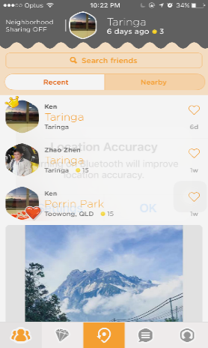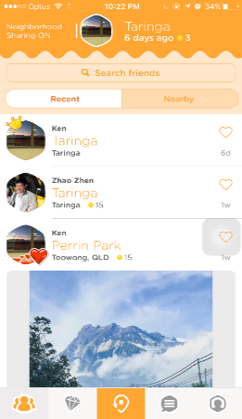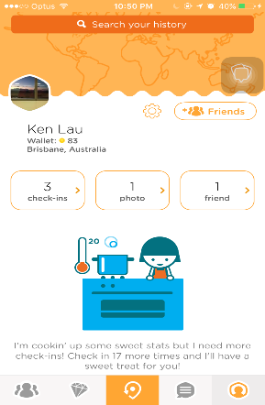

Home (History)

)

Neighbourhood (ON / OFF)

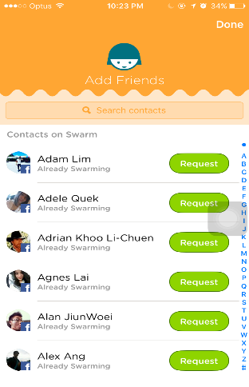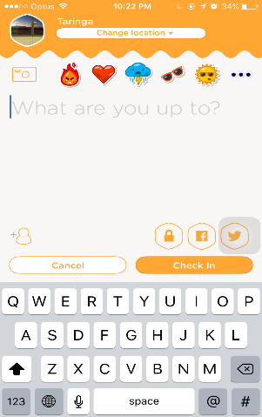

Add Friends

)

Check-ins

)

**Description:** Swarm is absolutely great location tracking app these days. It is available on iOS, Android and Windows to let users to share their locations to each other. It allows users to check-in to given location and let your own friend know and see who is nearby.

**How to Use:**

1. Launching the app will the bring users to the page which listing out all check-in activities of their friends.
2. Users can invite new friends who is currently available on the app through search bar located on the first tab in the bottom navigation bar.
3. Users are allowed to track their history along with the photo taken, chat messaging and all the past check-ins.
4. To receive the recent check-ins of friend, users are required to swipe down the screen of app.
5. Users will get notified when they are in range of required distance through the neighbourhood features. Users can turn it on or off to save up their devices’ battery life or data usage.
6. Users can check-in to the given location along with uploaded photos by pressing the third icon on bottom navigation bar.

Designs & Interactivity:

**Positive**: The appropriate use of component model and user interfaces is incredibly well designed in the app. The great use of graphical animation and text customization make it more attractive and favourable to the users who looks for interactive use. The opening page of swarm will display you a list of where your buddies are and also with your recent check-ins. It is easier to use as they are all arranged in chronological order with necessary details such as how long they have been away or check-in to given location.

**Negative**: The navigation of activities is not well designed in the app. Users are given multiple navigation to the particular or same activity as this might be frustrating or confusing to those users who are not familiarly good in using mobile devices. For instances, users are allowed to add friends through search bar or add friend’s icon which located on profile page. The icon design is not fairly well designed as there are no text display around the icon on navigation bar. The first-time users may not understand or familiar which tab should they pressed for the particular activities.

Features & Functionality:

**Positive**: It is one of great messaging, location sharing app and it was fun and trendy for a while. Users can easily search and find the person that they are looking for in just seconds. Users can check-in to given location and share it to their own friends or families from contact list. Besides, users can easily know how many people have publicly checked in to the location by clicking one of recent check-ins of their own friends. Furthermore, Swarms has great feature which allow users to broadcast the plan to the nearby friends who follow them on the app. However, they have to be in required range of distance to be notified who is nearby. Although users are not given to share their location within group chat but they can tag locations that currently stored in the Swarm database. It will link to small map along with the brief description of what are restaurant or landmarks at nearby. Users can start message with one-to-one or group conversation along with the feature of sharing photos and stickers.

**Negative**: Although it is great app for location sharing, but it also drains the battery life faster especially when the neighbourhood sharing feature is turned on. The feature will keep using your battery life as it runs on the background even you have completely exited the app. The users are required to turn on feature if they want to let their friends and families know where they have been up to. On the other hand, users are not given to share their location in the individual or group chat conversion within the app. They have to enter the current location by themselves along with location tags. This might be hard for those users who are not familiar to the city. To look at the entire venue details, the users are required to switch to the Foursquare app which is one of app that integrated with the Swarm. It allows the users to view nearby business location, landmarks and restaurant.

**Design Guidelines**

* **Colour Scheme / Theme**

The primary theme colour for our app will be white in color. White colour would give the app a nice and clean feeling (Charles Eames, 2014), whereby this style is used in many popular applications such as Instagram and Facebook. Our tabs will have a darker shade of white in order to keep the colours consistent, but at the same time we do not want it to look too plain. As we have decided to go with a light coloured background, our text will be dark coloured in order to ensure readability for users (Google Design Guidelines, 2014). This consistent and functional use of colours is clearly evident in all of our reviewed apps, whereby the colour contrast and consistency is present.

* **Navigation**

Navigation is another crucial area as it will ensure whether an application is user-friendly or not (Jacob Gube, 2010). Users tend to be annoyed with applications which are hard to navigate around. For our app, there will be three main tabs which users can navigate around. It will be placed in the upper half of the screen to ensure that users can easily move around regardless of which page they are in. An example of good navigation could be seen such as in the QUT BlackBoard website, whereby the main navigation tab is seen in all pages on the top left corner. We will be ensuring that our application will be extremely easy to navigate, and may include features such as swiping left or right to change tabs.

* **Buttons**

Buttons communicate the action that will occurs when the user touches them. For example, tapping the home button on any android device will bring users back to the homepage. Rectangle material buttons are used in our application, such as the search button, request button, and such.

* **Search Design**

The search function allows users to quickly locate app content and retrieve information from databases quickly. The best type of designs offers a simple search box on the homepage (Jakob Nielsen, 2001). The search function must be implemented properly and placed in a convenient location for users to access it. We will be implementing the search bar on the homepage of our screen, which can be accessed easily. At most, it will take users two to three swipes to reach the search bar. Of course, we will have an action bar on the top of the screen which includes a search icon. This will direct users to the homepage instantly, with the search button in the center.

* **Layout Interaction**

The main interaction of our application features a swiping function, whereby users can easily navigate different pages by swiping left or right horizontally. Users can see the icons on the upper half section of their screen which includes the search icon on the left, recent contacts in the middle, and favourites on the right, giving them an indication of which direction to swipe. Many applications have implemented this feature in order to increase the user experience (Hyndman, R 2012), as swiping is much easier compared to manually tapping.

**Part B   
Executive Summary**This report was commissioned to provide an insight into our mobile application. Project Glados is a mobile application which allows users to find out information regarding their colleagues. This project is aimed at increasing collaboration between employees and also reduce the cost of interaction.

Key features include allowing users to request the location and/or status of colleagues, and allowing the colleagues to respond in a similar fashion. We will also be building our application with an extremely easy interface to provide ease-of-use for users. It will be easy to navigate around our app, whereby there are only three tabs for users to access to. Users will be able to interact directly with our app via notification, meaning they can respond instantly from the notification.

There will be additional features which will be implemented such as beacon integration, whereby beacons will be placed in key locations or locations derived from WiFi hardware e.g. modems. We will be integrating the beacons with indoor mapping capabilities, and this will be done using sample floor plans synchronised with beacons. If time permits, we may consider implementing more interactive features for users, possibly a in-built chat system or something along the lines of that.

Our progress so far could be seen in the completed prototype screens, with some base functionalities included. Further details regarding our progress and future plans could be seen in our timeline and the upcoming presentation. We will be completing all the necessary functionalities before focusing on the interface and design of the app, which could be done later on. We believe that with our user-friendly interface and easy to use functions, we will be able to achieve Telstra’s goal of improving interaction among staff.

**WireFrame**

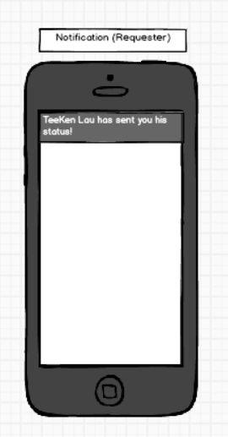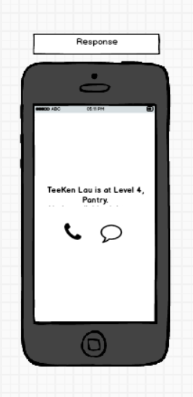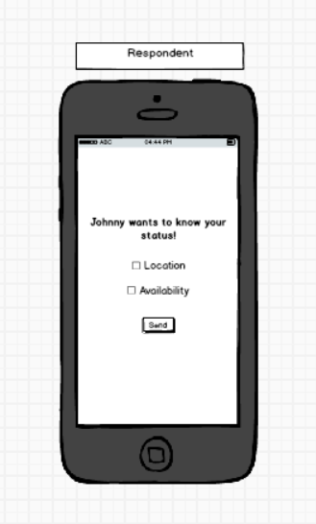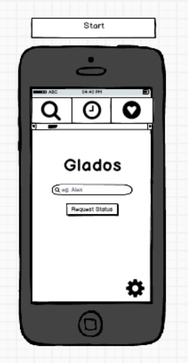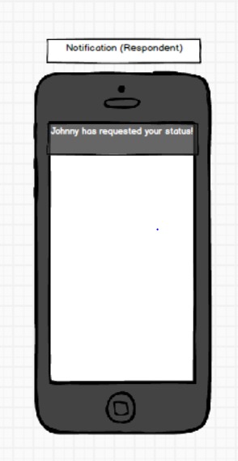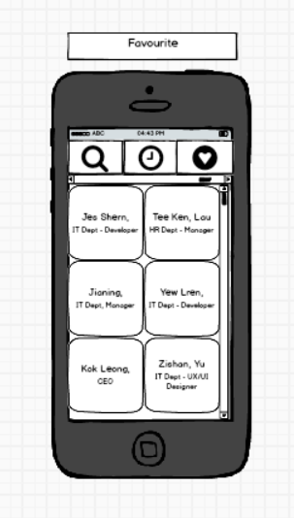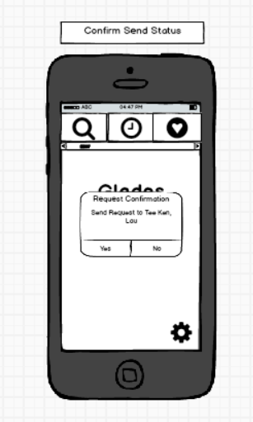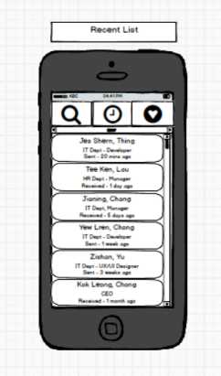

Tick on checkbox for type of information to be sent. Press send to confirm.

Notification from requester along with the name (Clickable)

Tap on a recent contact to request status. Contact details include name (first & last), department, type and time of request.

Choose Yes to confirm request, No to cancel

Tap on a contact box to request status. Contact details include first name, last name and department.

Search by name (Suggestions below search) and request location of certain person

Information is displayed based on the respondent’s selection of location and availability.

if unavailable, only the message link is displayed to avoid disturbance.

Notification from respondent along with name (Clickable)

**User Stories and Associated UI**

Git URL: <https://bitbucket.org/shiftmybits/telstraapp>

|  |  |
| --- | --- |
| **UI Prototype** | **Details** |
| Author: Yew Lren Chong | **User Stories:**  As a staff in Telstra (Requester),  I want to be able to search for a specific staff in my company  So that I can request their status.  **Acceptance Criteria:**   * Search for a colleague by name * A button to send request * Swiping and tapping feature |
| Author: Tee Ken Lau | **User Story:**  As a staff in Telstra (Requester),  I want to be able to view my recent contact list,  So that I can save time and request their statuses.  **Acceptance Criteria:**   * Recent contacts list * Tapping a contact directly sends a request * List time of requests (outgoing/incoming) |
| Author: Jes Shern Thing | **User Story:**  As a staff in Telstra (Requester),  I want to be able to request for someone’s status  directly from a favourites list,  So that I do not have to search for their contacts regularly.  **Acceptance Criteria:**   * Favourite contact page * Tapping a contact directly sends a request |
| Author: Jianing Chong | **User Story:**  As a staff in Telstra (Respondent),  I want to be able to receive a notification  And respond the notification by choosing What information to send,  So that I can provide a response to my colleagues  And at the same time, I can maintain my privacy.  **Acceptance Criteria:**   * Option to pick which status to send * Receive notification * Information of Requester |
| Author: Jianing Chang | **User Story:**  As a staff in Telstra (Requester),  I want to be able to receive a notification from the respondent,  So that I can know their status and availability.  **Acceptance Criteria:**   * Receive notification * Availability & Location of respondent * Icon to call or message respondent |

**References**

* Google Design Guidelines. (2014). Color. Retrieved from   
   <https://material.google.com/style/color.html>
* Search Bar Design Guidelines. (2012). Retrieved from  
  <https://material.google.com/patterns/search.html>
* Nudelman, G. (2013). Android Design Patterns: Interaction Design Solutions for Developers. Somerset, NJ, USA: John Wiley & Sons. Retrieved from <http://www.ebrary.com>
* Color – Style – Material Design Guidelines. Retrieved from  
  [https://material.google.com/style/**color**.html](https://material.google.com/style/color.html)
* Search Bars – UI Bars (2010): Retrieved from  
  [https://developer.apple.com/ios/human-interface-**guidelines**/ui-**bars**/**search**-**bars**/](https://developer.apple.com/ios/human-interface-guidelines/ui-bars/search-bars/)